C I

Festival
AUGUST 14 10:00am
EVERYTHINC

- Haircuts• Dental Exams•
- Vision Exams & Health Screens•
- Backpacks filled with School Suppies•
Join us for this community-wide event to show our love & support for students and teachers as they begin the school year!

  - Prizes
  - Giveaways
  - Games
  - Bounce House
  - Gift for Students & Teachers

Free Meal
Live Music
Blessing of Backpacks Short Devotion Elected Officials

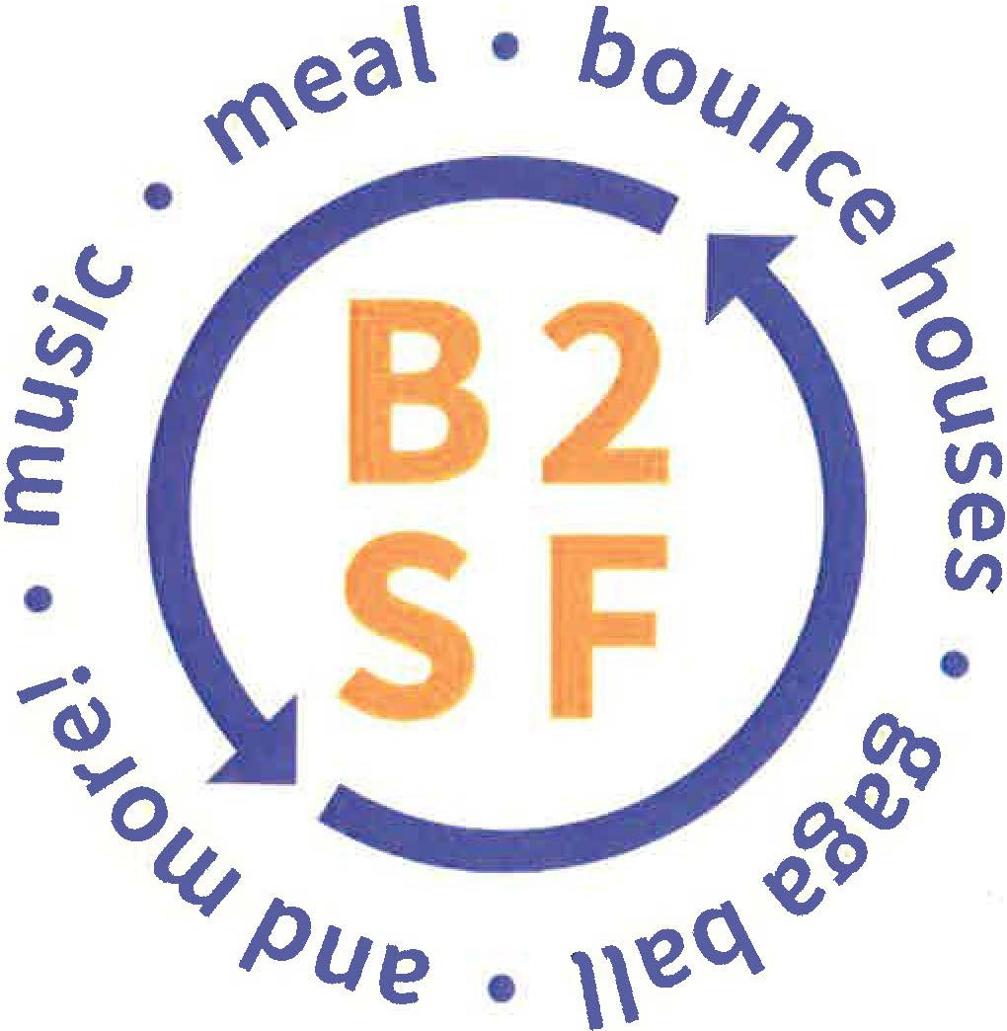Angleton First United Methodist Church
219 N. Arocla • (979) 849-6305 • church@angletonfumc.org

